City of Tetonia
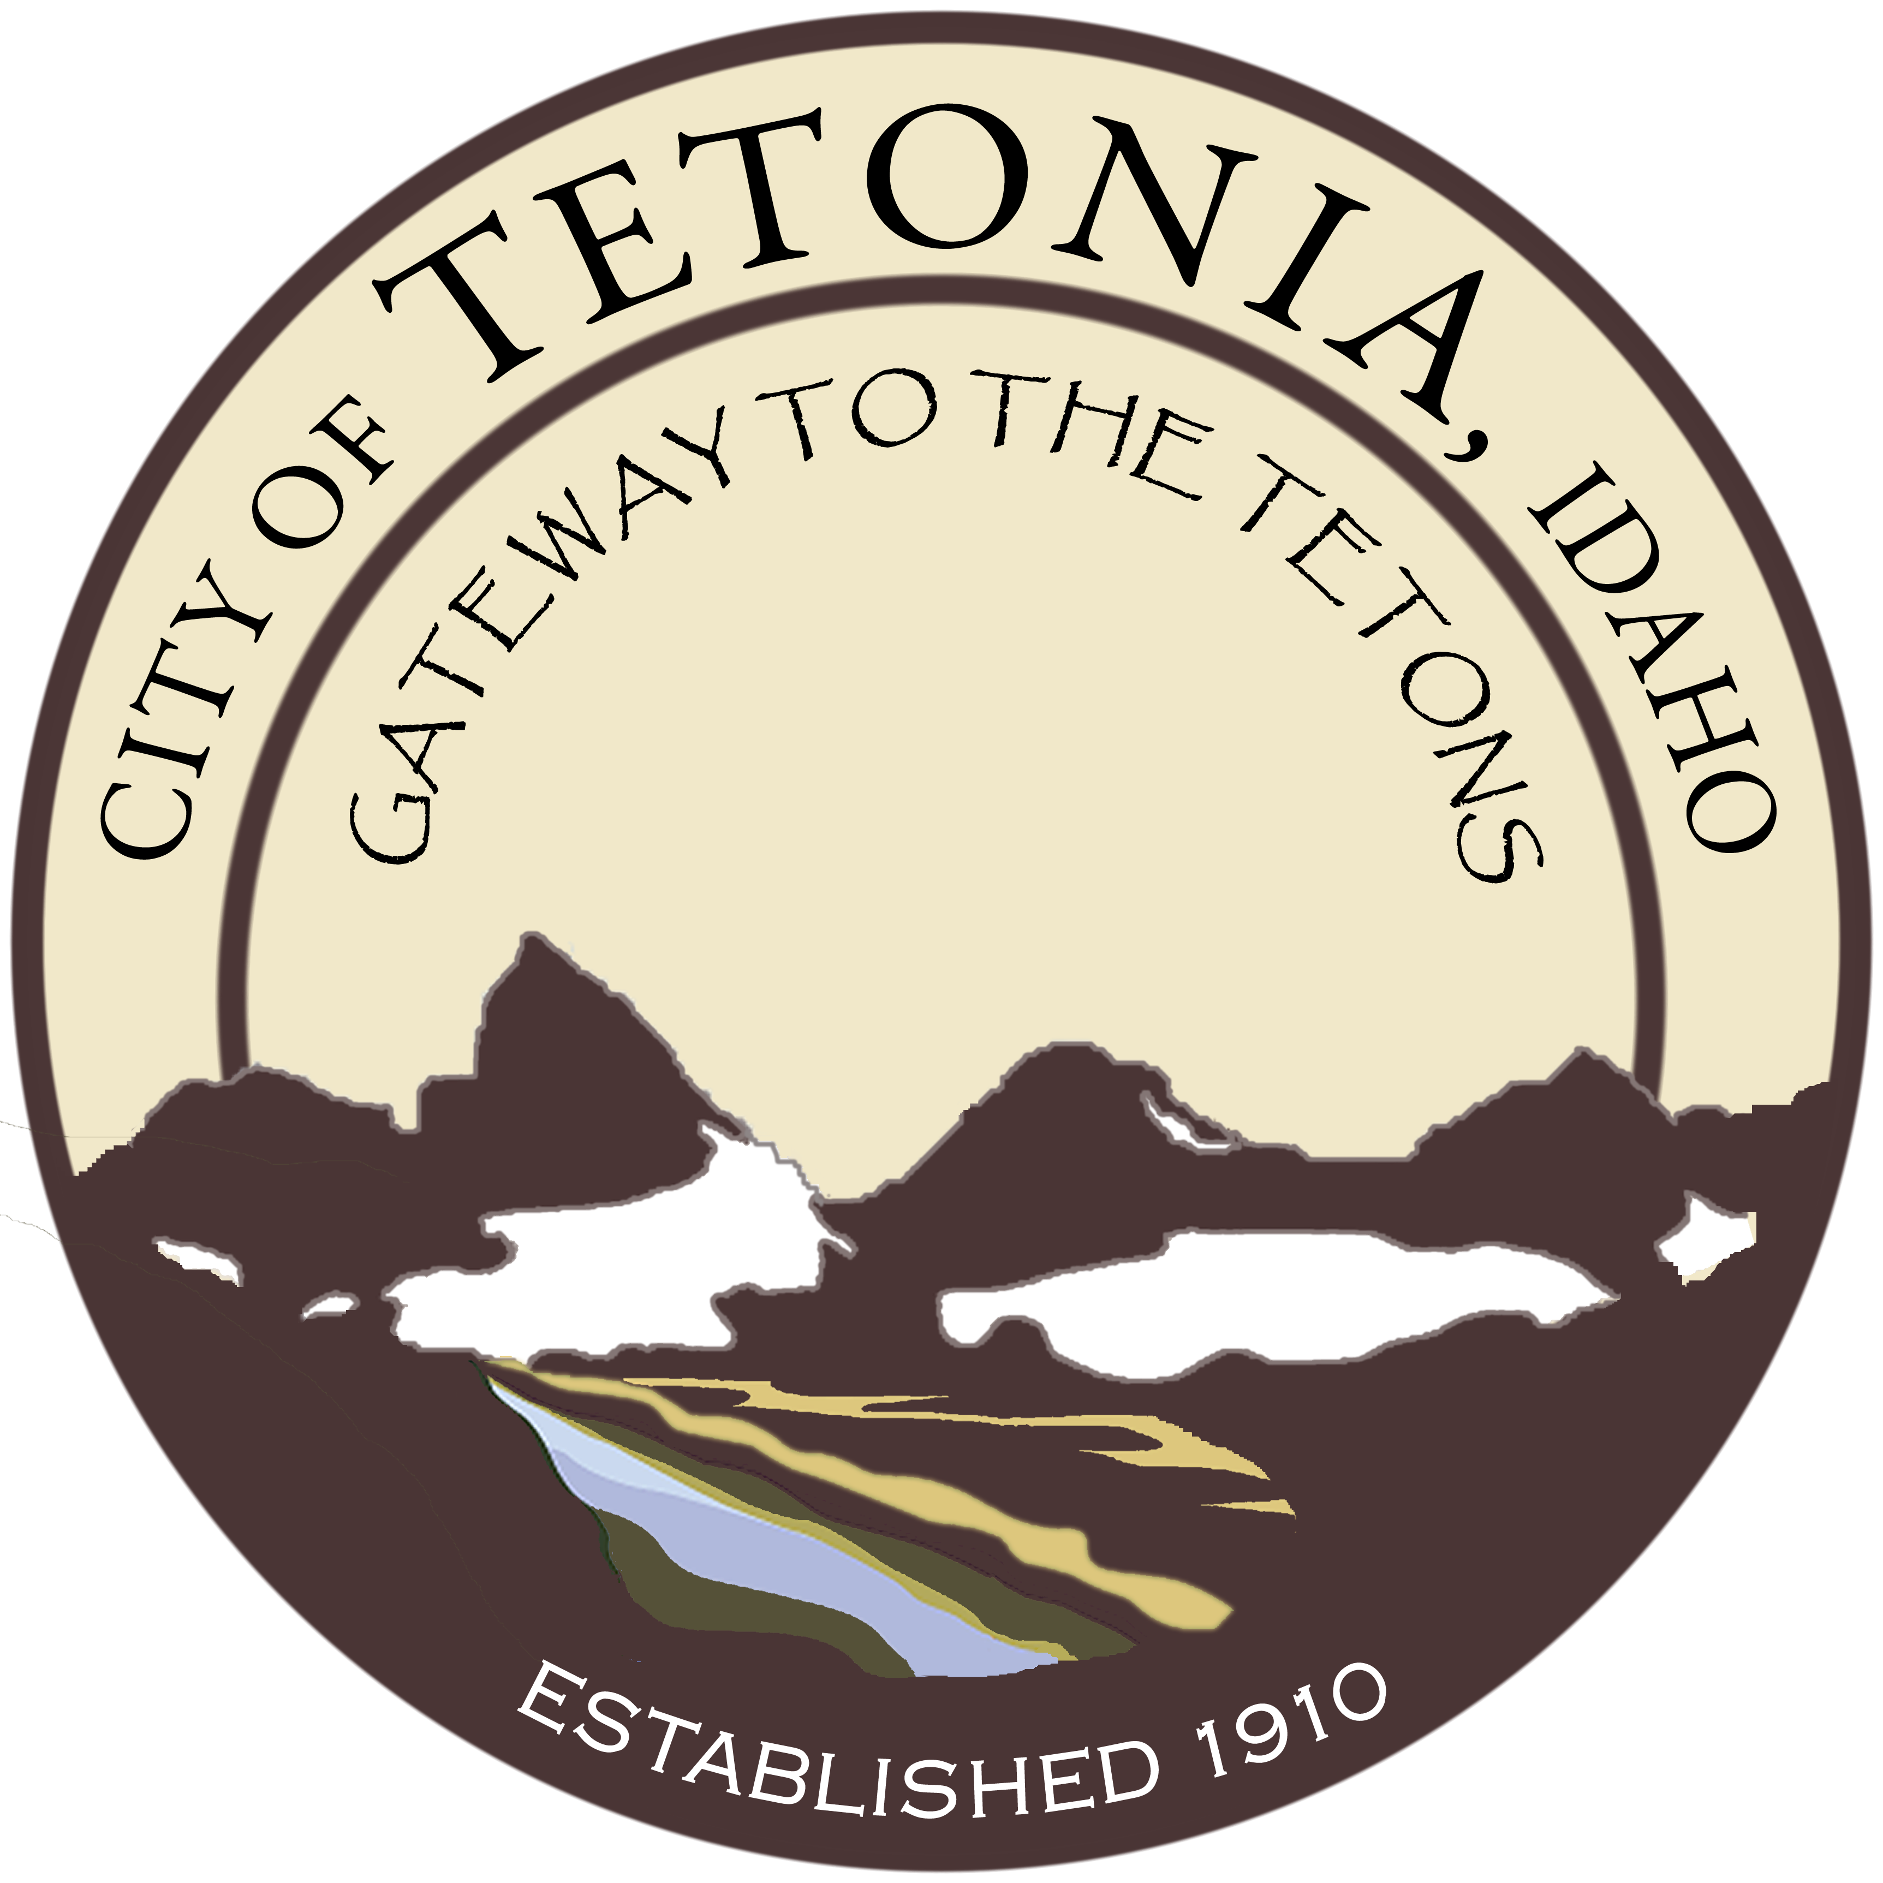
Regular Council Meeting
City Hall-3192 Perry Ave
June 12, 2017

Open Meeting
Call to order by Mayor Gloria Hoopes 7:03 pm
Pledge of Allegiance
Roll call by Clerk – Council President, Tom Abbott; Council Member, Bucky Matkin; Council Member, Aaron Hansen; City Attorney, Bart Birch; , Nanci Garling, Council Member was excused.

Bucky Matkin moves to amend the agenda stating the “good faith reason” that there is the potential for a new event which was not known prior to the posting of the agenda, Tetonia Capital for the Day – Idaho Governor’s Visit.

Aaron Hansen – seconds the motion.

All in favor. Motion carries.

Mayor Hoopes – We have been contacted by the Governor’s office asking if Tetonia would like to be “Capital for the Day”. The governor would like to come and spend the day in Tetonia. We would need to provide lunch and get a crowd out for the event. Is this something that the Council would like to do?

Everyone is in favor of having Tetonia be the Capital for the Day.

General Business

Water Project – Update from Mayor. Mayor Hoopes – I have signed plans for the DEQ for the water project, so it is moving forward. When I was in the Forsgren Office I mentioned that we would be having the Dutch Oven Cook-off and an event the night before the Eclipse. Forsgren would like us to have the drilling area fenced off. I thought we could get some of that orange plastic fence and we could use it for other events as well.
Bucky Matkin – That stuff usually comes in 100 foot roll.
All agreed to have Mitch Beard get some orange plastic fence material to fence off the drilling area when they start drilling the well.
Consideration of Water Rate Increase Resolution. Discussion regarding the increase of fees which is required in order to build up a reserve to make payments to the USDA for the monies received from them toward the water project.

Tom Abbot – I move to pass Resolution No. 2017-1, Debt Repayment and O&M.
Bucky Matkin – I second the motion.

All in favor. Motion carries.

Dutch Oven Cook-off – July 29, 2017. Mayor Hoopes – We need help getting everything done for the Dutch Oven Cook-off. If anyone knows of anyone who may be interested in being a contestant, please contact them and have them contact the offices.

We also need to get sponsors and good prizes. We need to let people know early enough to make sure that they don’t have other plans. They can sign up at the door. July 29th is a Saturday.
For the dinner that we serve to the public, the City can supply a green salad so we just need someone to cook and serve meat and potatoes.
Bucky Matkin – I suggest that we have chicken tender because they are fast and simple. I don’t think we need to have any rolls.
Mayor Hoopes – I think we should talk to Tim Brower first to see if he will cook the meal for the public.
I suggest that we have Jon at Badger Creek Café’ be a judge. We could also have Darlene Vestal who cooks at the Elementary School be a judge. Does anyone have any idea who we can use for a third judge?
Jean Hansen, Clerk – The times are the same as last year; contestants need to be on site at 4:30, judging begins at 5:30 and the dinner is served at 6:00.
Mayor Hoopes – We will start serving dinner at 6. And we will charge $5.00 a ticket for a tasting ticket. People can pay $5.00 and they can taste the various dishes and vote on them for the People’s Choice.
Potential sponsors for this year’s event could be Cal Ranch, Broulims, the propane companies, Fall River and maybe Forsgren.
Eclipse – August 21, 2017. Mayor Hoopes – I went to a meeting on Friday. There are now two committees involved in planning the Eclipse, the county committee – and the continental divide group. The continental divide group is doing everything for a profit, and the county is working toward doing everything for safety and health.
I turned down the offer of porta potties – at $750 for a week – cleaning it once. I did sent information to businesses who might be interested.
Continental divide has created two information centers in Driggs and Victor. They wanted to set one up near Tetonia. I said the City of Tetonia can do one. I would propose that we buy one of those pop-up tent things, we can use it again for other events. I think that anything that we buy to use for the eclipse should be something that we can use for other events.
In our booth we would have information and we can put together a small colorful map for just the businesses of Tetonia. The County will have a similar thing.
We will communicate via radios. All volunteers should be in safety vests. That will signify an official person. We need to find some volunteers to man our information booth.
There is a letter going out to ask for information from the businesses – so we can make sure that everyone knows what each business is doing.
The County is going to have a trial run on July 19th – set up similar scenarios to see if there are any areas that need to be worked on.
No one knows how this is going to be – nothing like this has happened before in our area.
I have told the Café that they can put up signs that restrooms are for customers only. Dave said he is going to open the bar at 7:00 am so they can use the restrooms
We could also sell water and charge $1.00 a gallon for water.
Budget – FY 2018. Mayor Hoopes- We need to dedicate another work session or two to work on the budget. Let’s set the next two Mondays as work sessions – Monday 19th at 7:00 pm – if not completed do more on the following Monday 26 – all in June.
Public Works
Received authorization to order the solar control radar speed signs and to take the funds out of the road budget. Also authorized to get pop up tent for information booth and to pay for it out of the general and streets.
Planning and Zoning
Nothing to report from the P&Z Board. Mayor Hoopes noted that there is a lot more interest in development of private homes and possibly commercial structures in the City.

Consent Agenda
Approval of Minutes – Minutes were approved with two corrections noted by the Council
Claims and Revenue – Claims and revenue was approved by the Council.
Aging Report/Delinquencies – seriously past due accounts were noted and instructions were given to hang shut off tickets on their doors.

Adjourn
Tom Abbot – I move to adjourn the meeting.
Aaron Hansen – I second the motion.
All in favor. Motion carries.

