Happy New Year Everyone!
I hope everyone had a wonderful Merry Christmas and Holiday Season.
Let’s hope our new year goes well for everyone. We have had a beautiful, but cold, start to the year. Please remember to keep a small stream of water running in your home. We don’t want any frozen pipes.
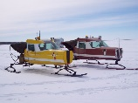Our major activity at the city office right now is planning for the Snow Plane Rally. The rally will be held January 20th beginning in the Ruby Carson Memorial Park and moving to the fields north of town as the planes make their circuit through the countryside. They will be giving rides to the public. They will have signs and announcements at the event instructing people where to go if they would like a ride. We hope everyone takes time to attend the event and enjoy the time with their neighbors and friends.
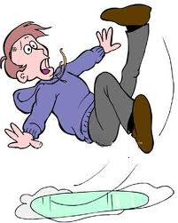
As usual for the winter we need to remind everyone to drive – and walk – carefully to avoid accidents. Mitch has done a great job clearing the snow from the streets. However, with the lack of new snow and
the cold temperatures the roads have become icy. This means extra caution for everyone.
Due to home sales this fall and many rental changes we have several new residents in our community and we would like to welcome them to the community. If anyone has questions about the city please stop in or call the city office for help and information.
Some community members in and around the city are hoping to have new community members and long-time residents get to know each other better. A group of people have started meeting the second Friday of each month at the Badger Creek Café for breakfast. Everyone is welcome and encouraged to attend. This is a great opportunity to know more of your neighbors and community members.
Also at the Badger Creek Café, they have created a mini-lending library. They have a good selection of books there for people to take to read and more room for people to drop off books they have read and would like to share. This is a win-win opportunity for readers and we would like to thank John and Elyse for this contribution.
Enjoy the winter, whether that means getting out and participating in sports and activities or cuddling up with goods books and staying warm!

Respectfully,
Gloria Hoopes, Mayor

