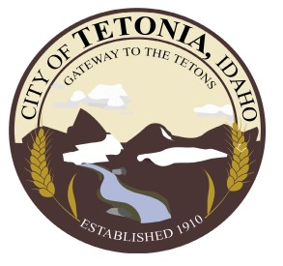
City of Tetonia
Regular Meeting @ City Hall
3192 Perry Avenue
April 11th, 2023 @ 7 P.M.
Open Meeting
- Call to order by Mayor Schindler
- Pledge of Allegiance led by Mayor Schindler
- Roll call by City Clerk

Public Hearing-

Action Items
- Michael and Jane Rammell, Water Lines- Discussion
- III-A Health Insurance Presentation - Action
- Budget Schedule for Fiscal Year 2024- Action
- Parking Ordinance Amendment- Action
- Consent Agenda- Action
  - March Claims
  - March Minutes
  - Past Due Accounts
  - Staff reports
- Enforcements, compliance updates- Action

Discussion
- Utilities Updates
- Blue Cross Foundation, Funding Opportunity
- AOI updates
- Claim resolution update
- Easter updates/ Future Events
- Mayor Updates

Executive Session per IC 74-206 Action
Adjourn Meeting

**Public Comments limited to 3 minutes.

