City of Tetonia
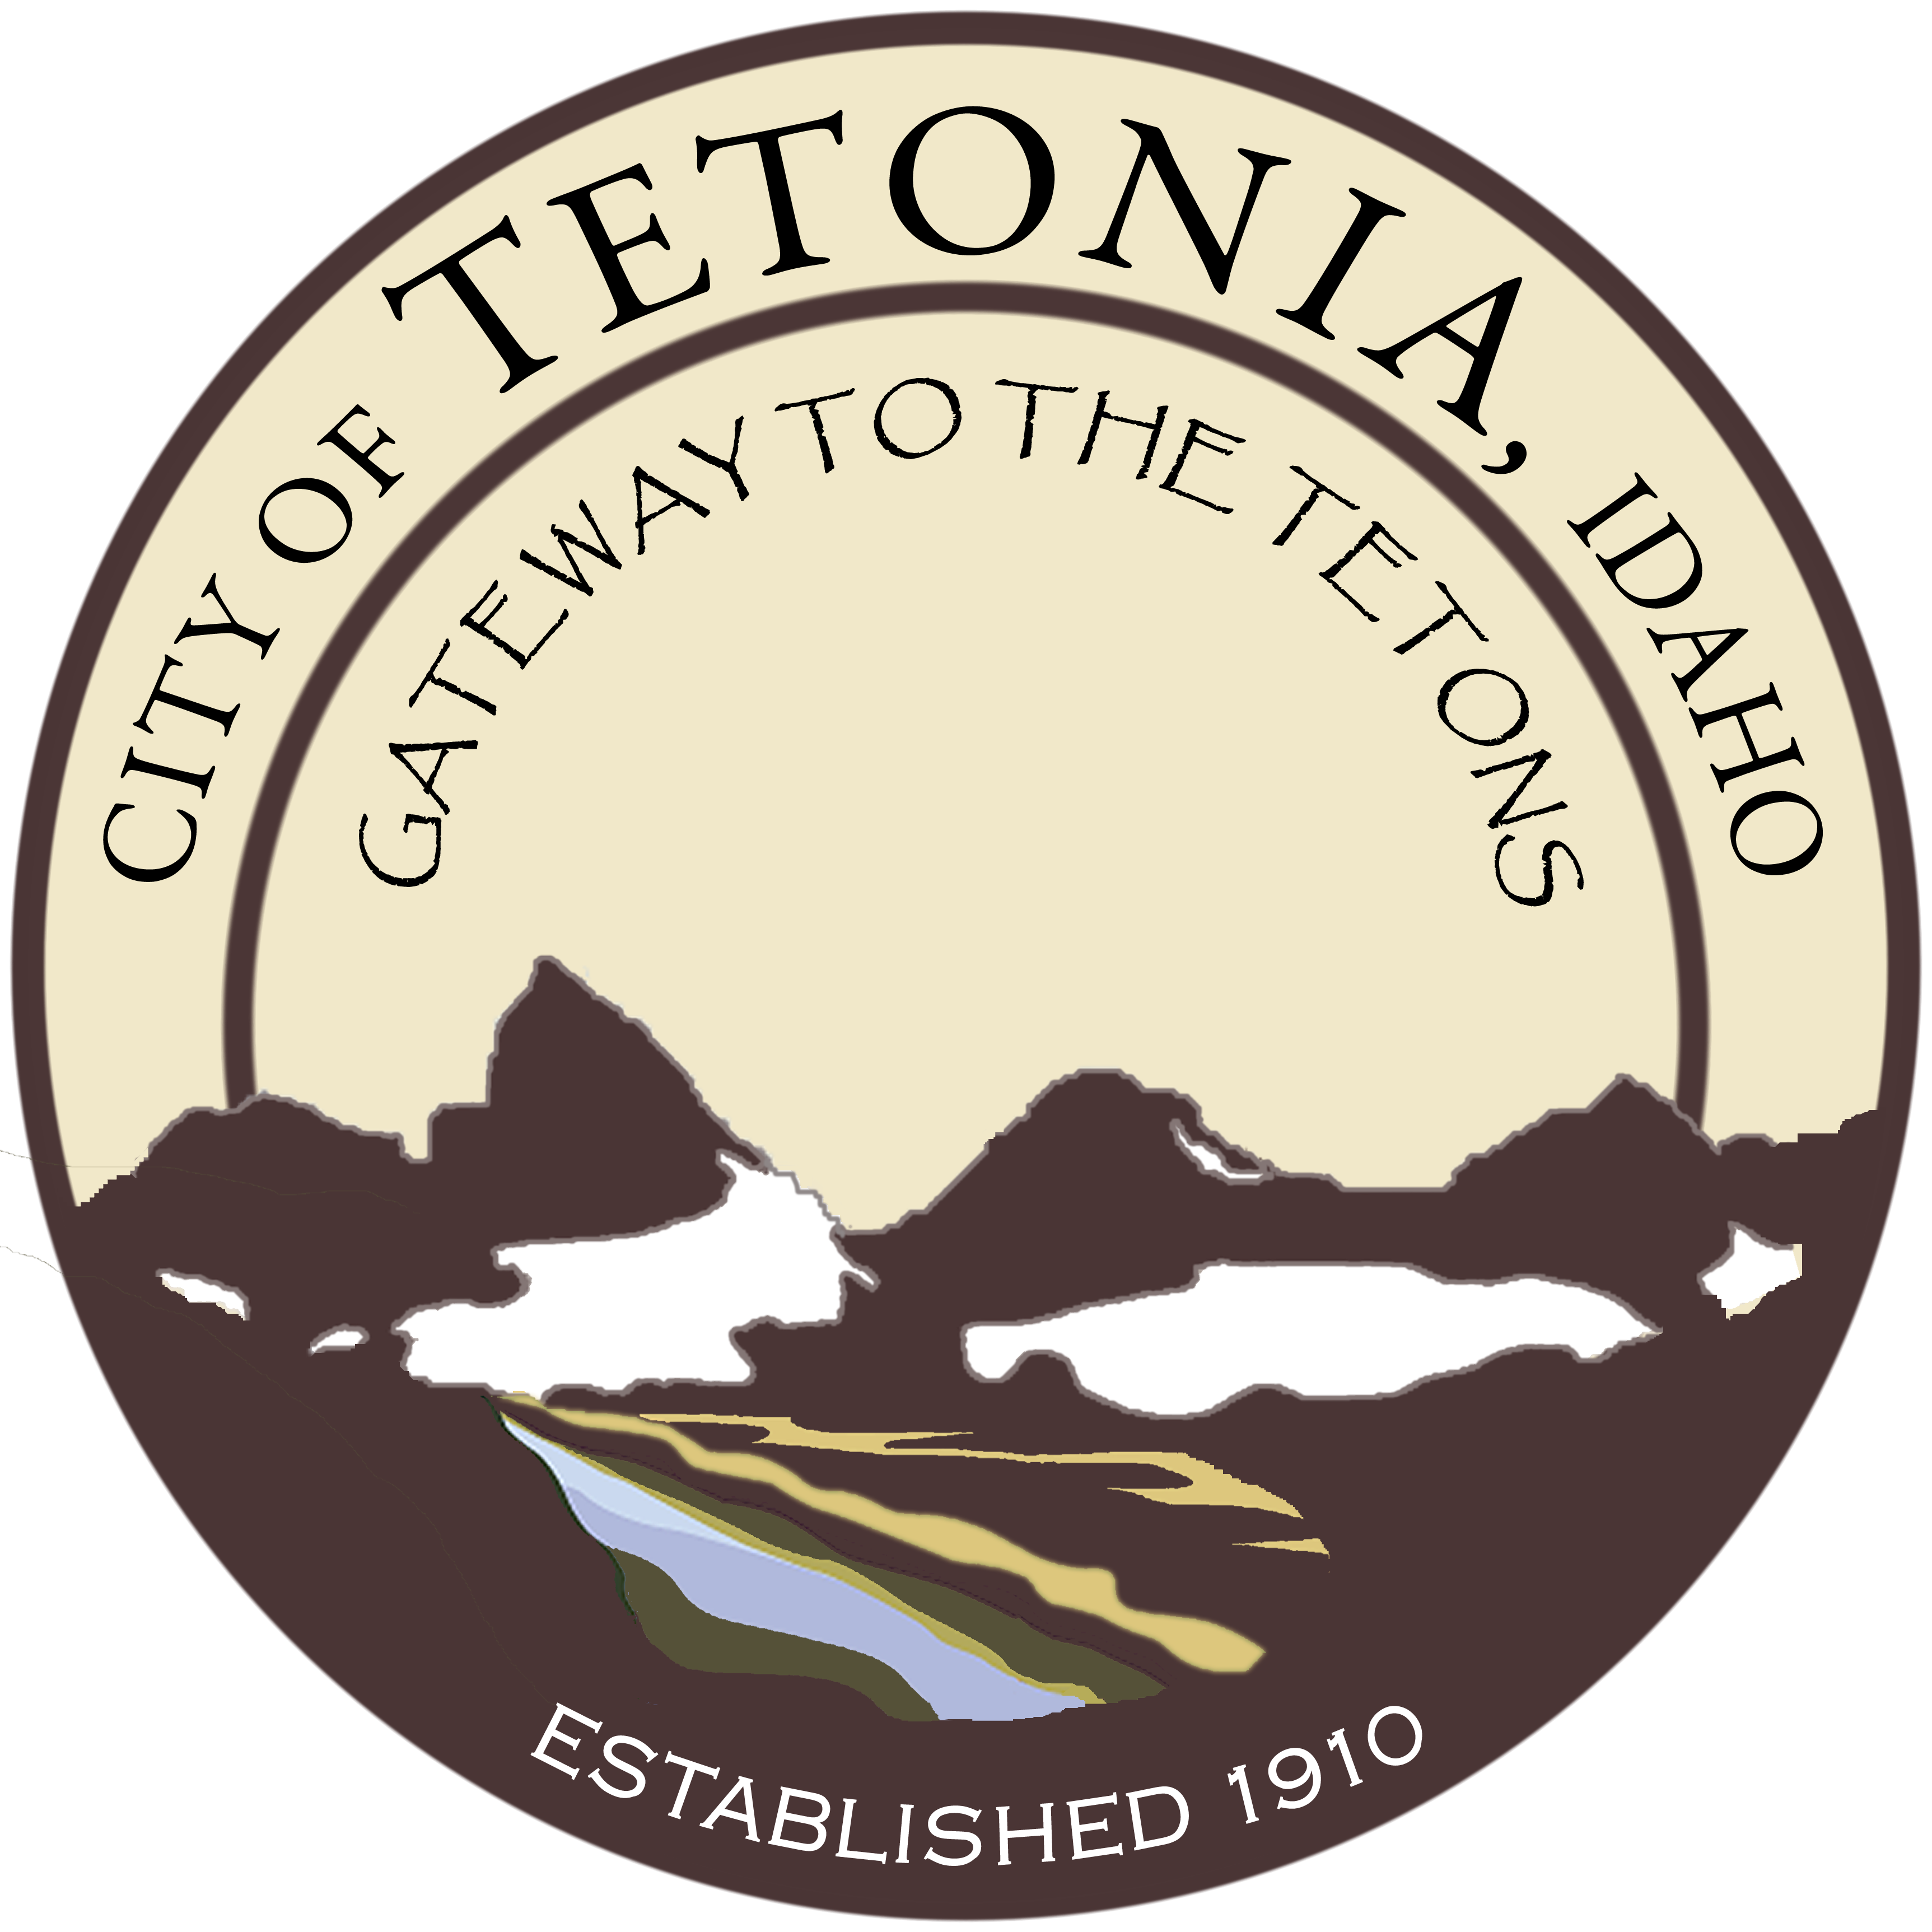
Tetonia City Council -
Regular Meeting
City Hall-3192 Perry Ave
July 10, 2017 – 7:00 pm

Agenda
Open Meeting
- Call to order by Council President/Pledge of Allegiance
- Roll call by Clerk
- Amended Agenda if needed (stating the “good Faith” reason why in Accordance with Idaho Code 67-2343)

General Business
- Community Block Grant – Rick Miller, The Development Company

- Water Project – Update from Mayor

- ICRMP – sewer back up claim

- Budget 2018 – Update (consideration of establishing fees and increasing fees)

- Logo – consideration of new coloration of existing logo

- Events – Update from the Mayor

Public Works

Planning and Zoning

Consent Agenda

- Approval of Minutes
- Claims and Revenue
- Aging Report/Delinquencies

