City of Tetonia
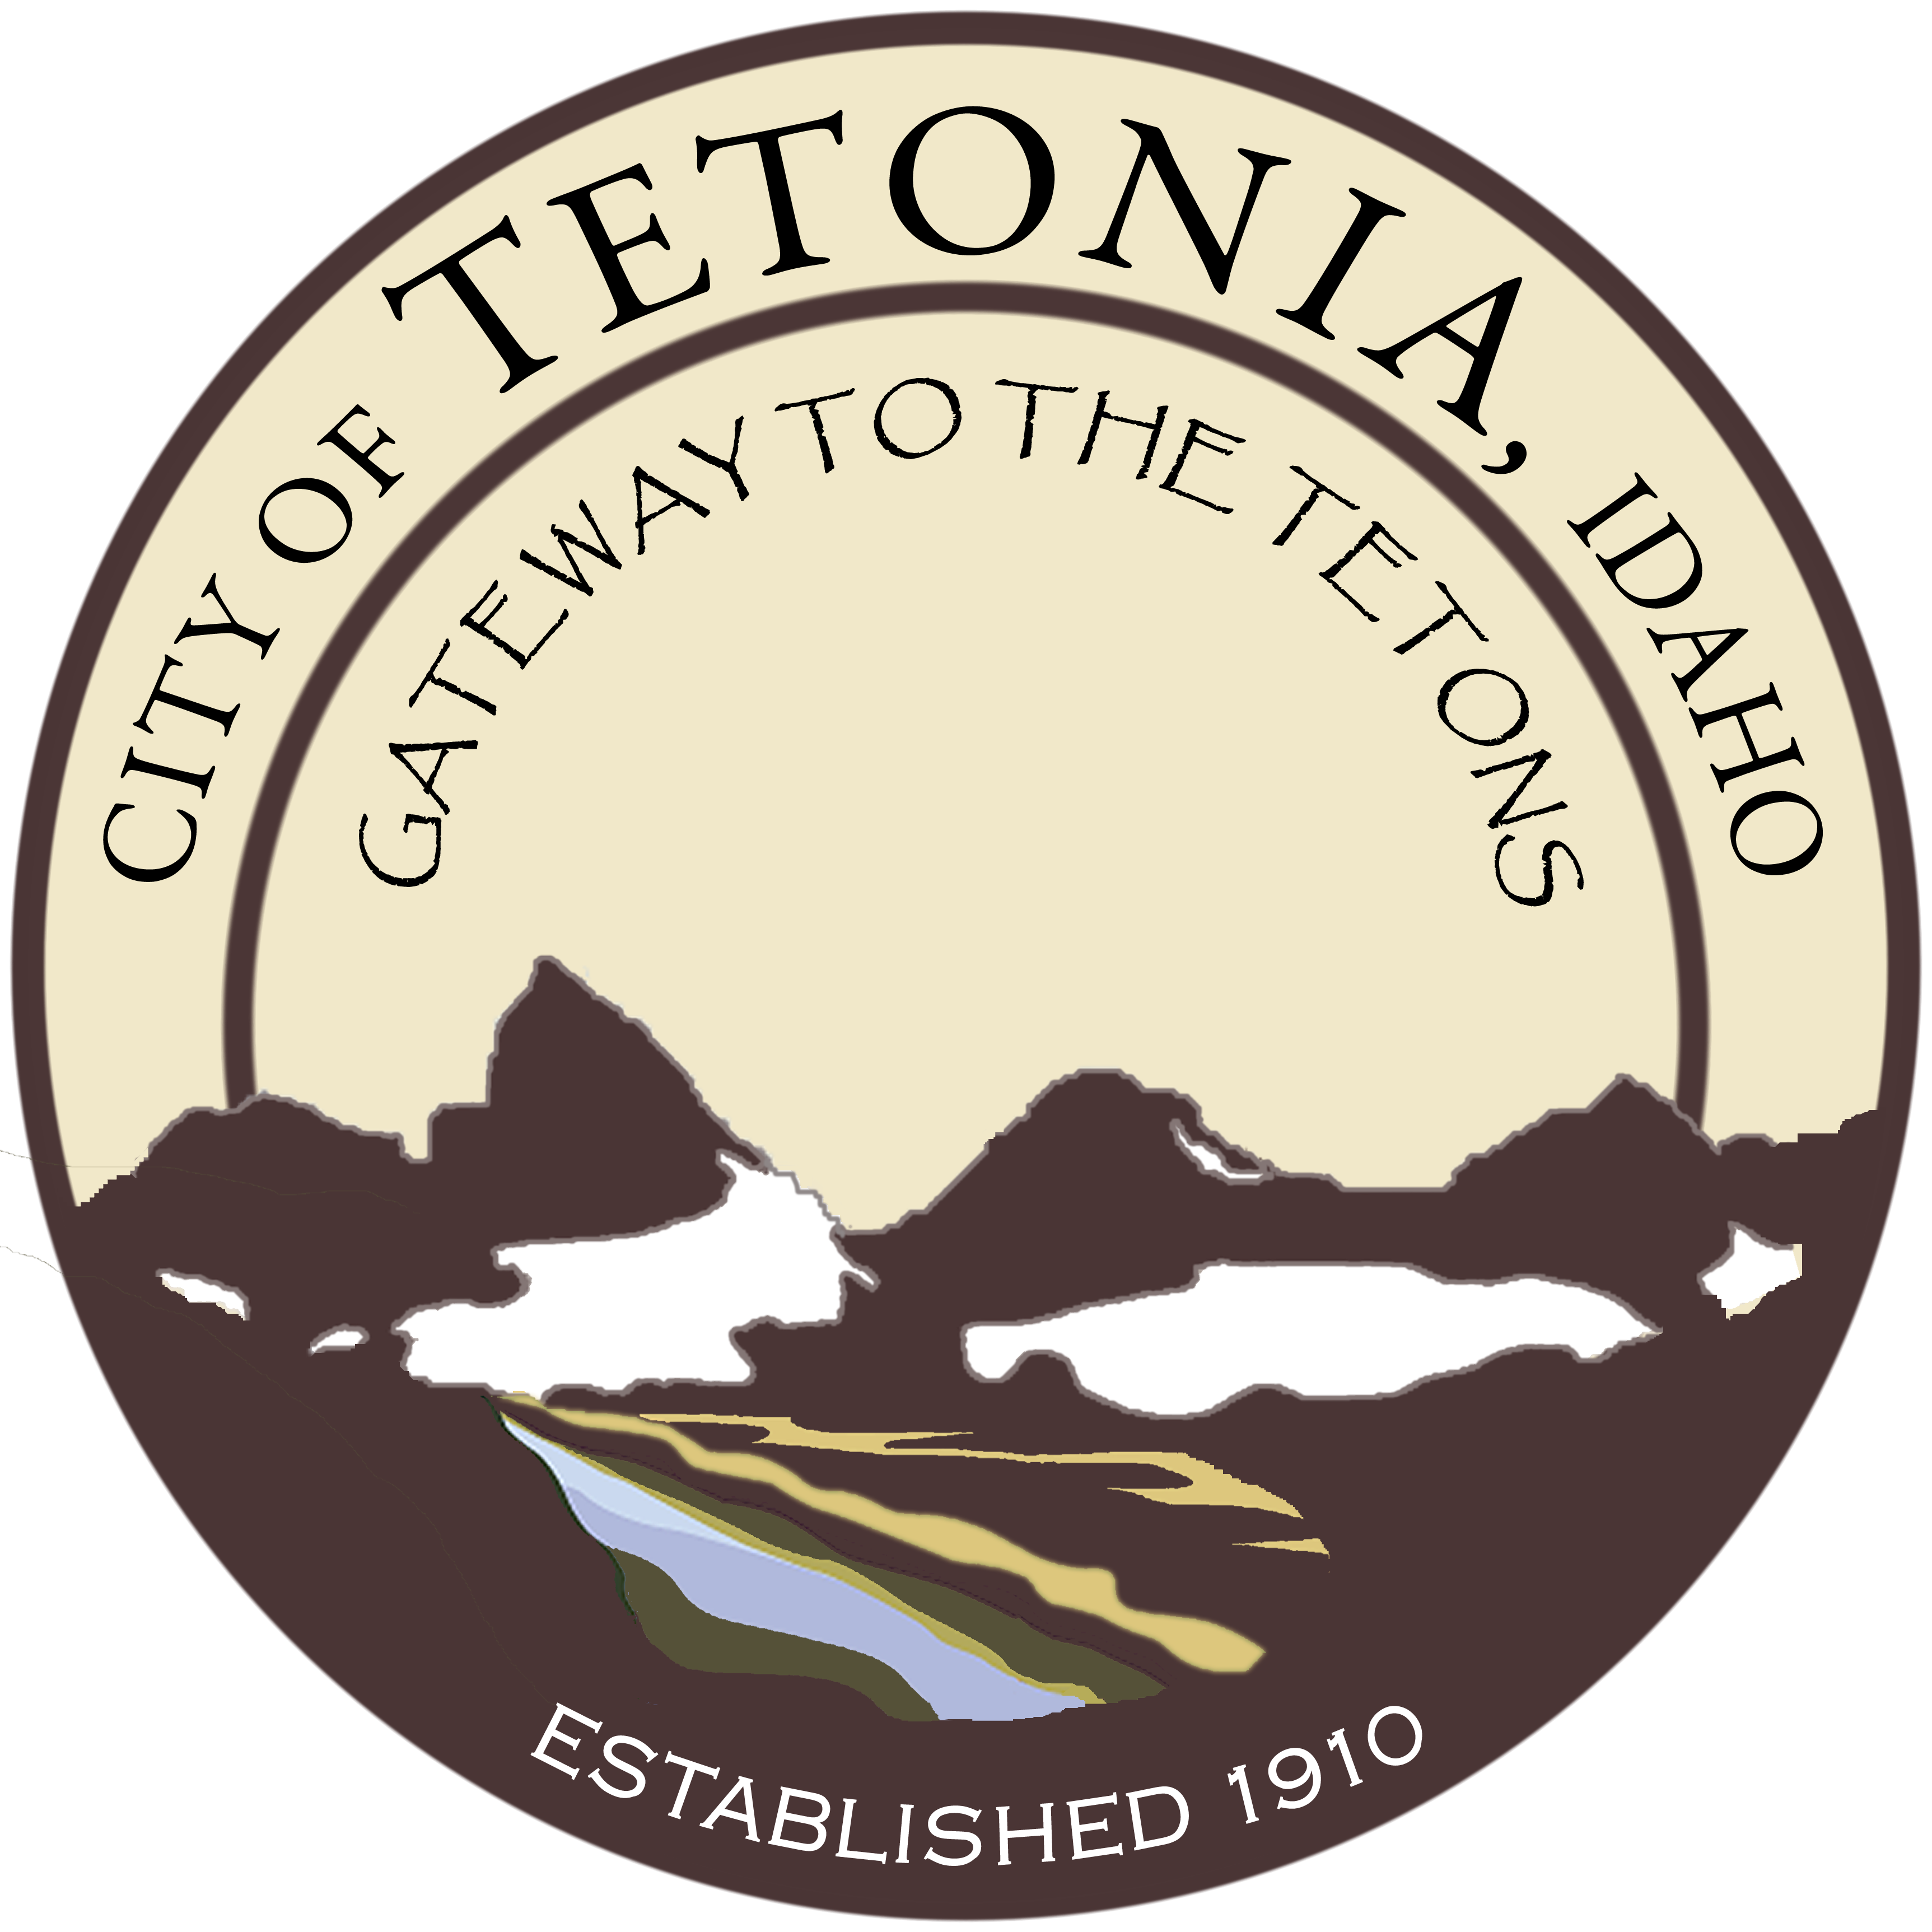
Tetonia City Council
City Hall-3192 Perry Ave
August 14, 2017
7:00 pm

Agenda
Open Meeting
The requirements for the opening of the meeting will have been fulfilled as a part of the
opening of the Public Hearing which took place immediately prior to this meeting.
General Business

- Water Project – Update from Mayor
  - Adoption of the “Policy Regarding Nondiscrimination on the Basis of Disability”
(one of the requirements for the receipt of Federal Funding)
- Review of rate increases as determined by the Mayor as directed by the Council
- Logo – potential change
- Events – Update from the Mayor
Dutch oven Cook-off
Report for 2017
Select a date for 2018
Eclipse
Volunteers needed for the information booth
Other volunteers possibly needed
“Starry Night Gazing” – see attached flyer
Tetonia Rodeo Grounds
- Potential Update of the Comprehensive Plan

Executive Session
Public Works
Planning and Zoning
Consent Agenda

- Approval of Minutes
- Claims and Revenue
- Aging Report/Delinquencies

