City of Tetonia
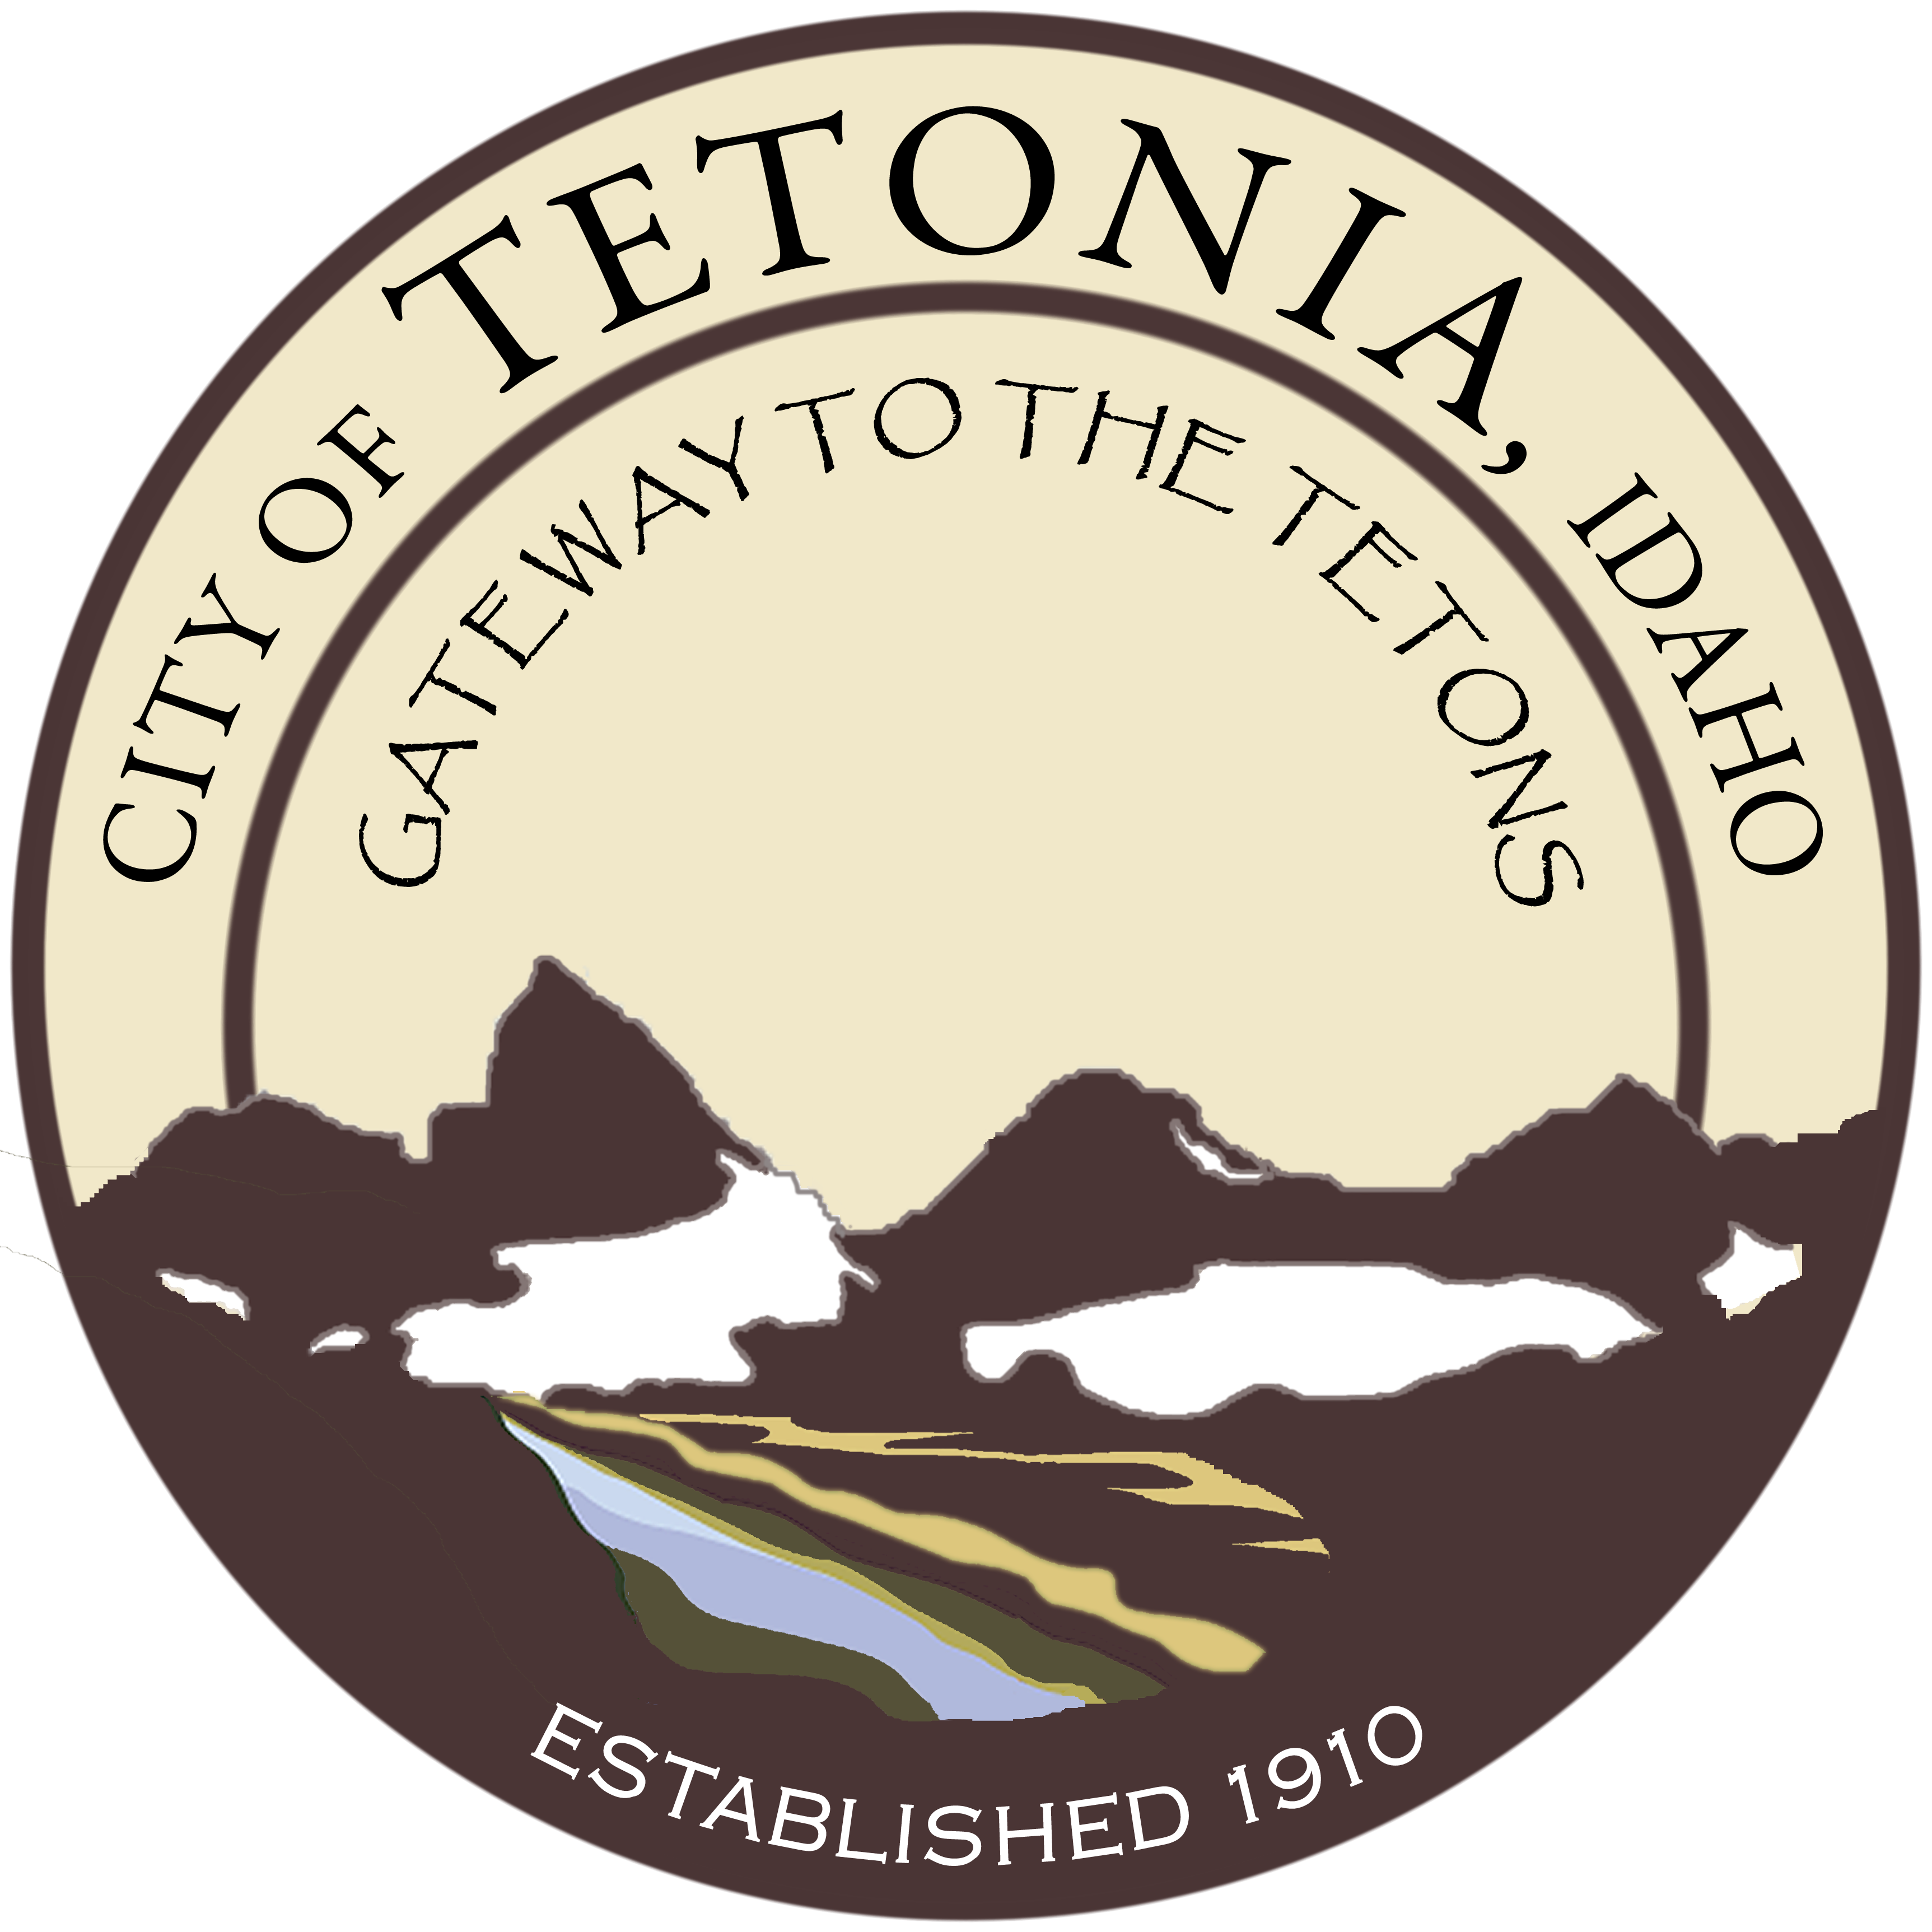
Planning and Zoning Meeting
City Hall-3192 Perry Ave
May 1, 2017

Agenda
Open Meeting
- Call to order by Council President/Pledge of Allegiance
- Roll call by Clerk
- Amended Agenda if needed (stating the “good Faith” reason why in Accordance with Idaho Code 67-2343)

General Business

- Paradis Garage Addition
- County Boundary Line Adjustment for Egbert Land

